Create Phonegap project in IntelliJIDEA

Step 1: click Create New Project

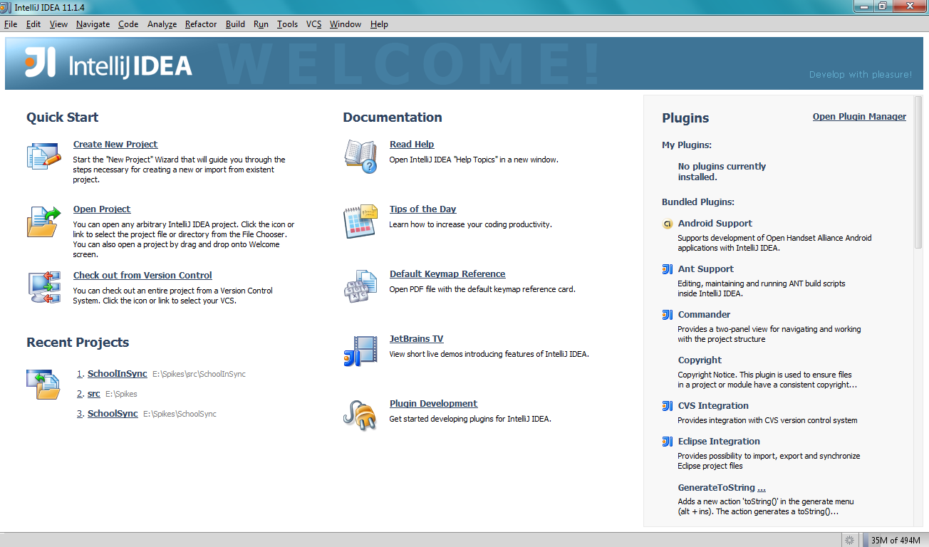

Step 2: Click Create a new project from Scratch

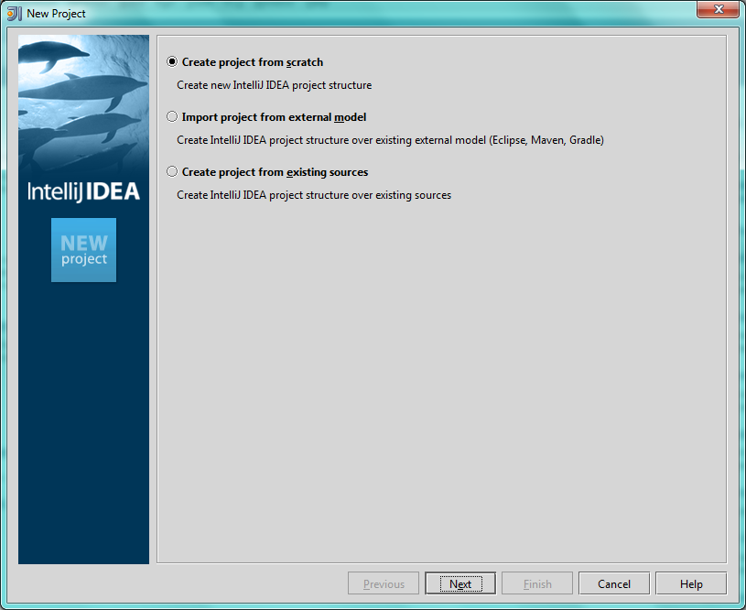

Step 3: Provide Project name & location and select type as Android module

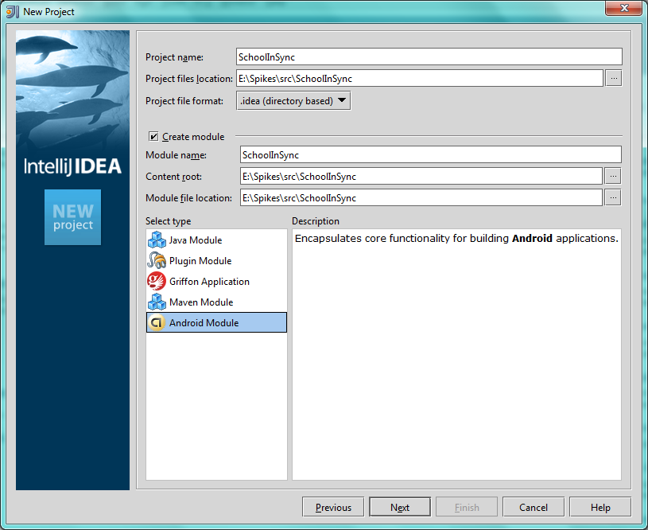

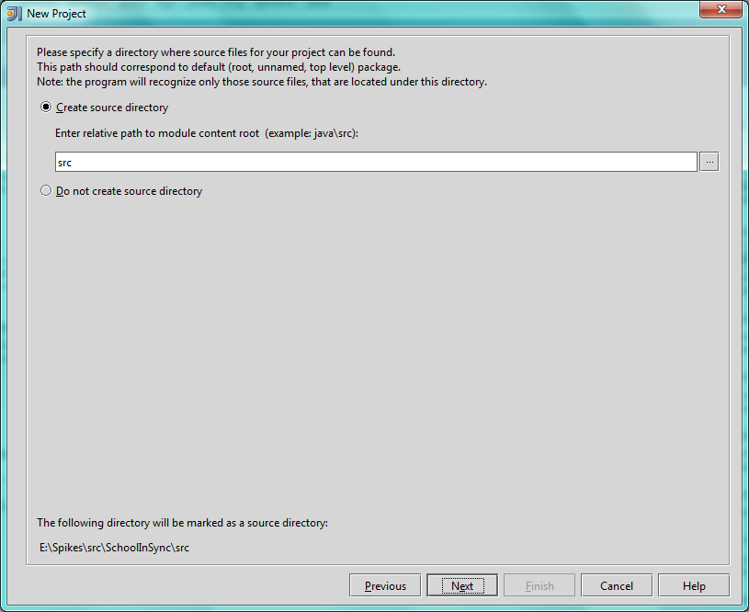

Step 4: Select Android SDK and project type as application and provide name for application, package and activity and select target device as USB or Emulator

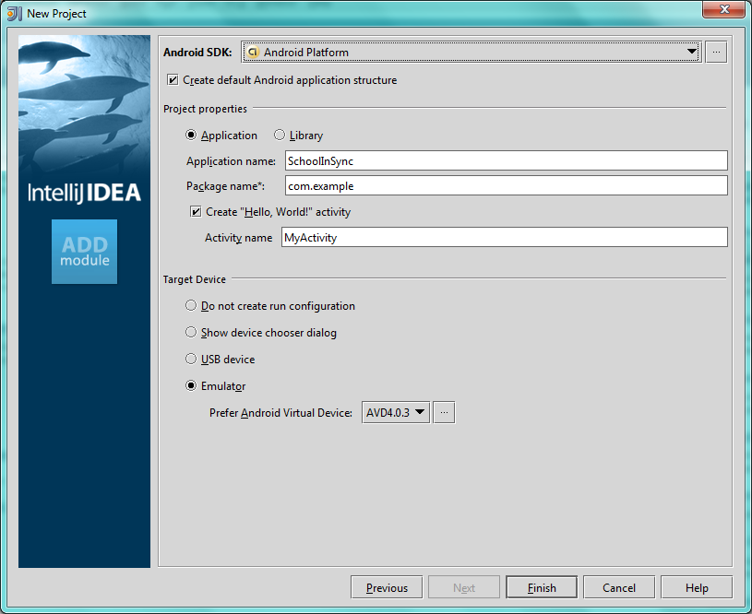

If Android SDK not configured, then configure it

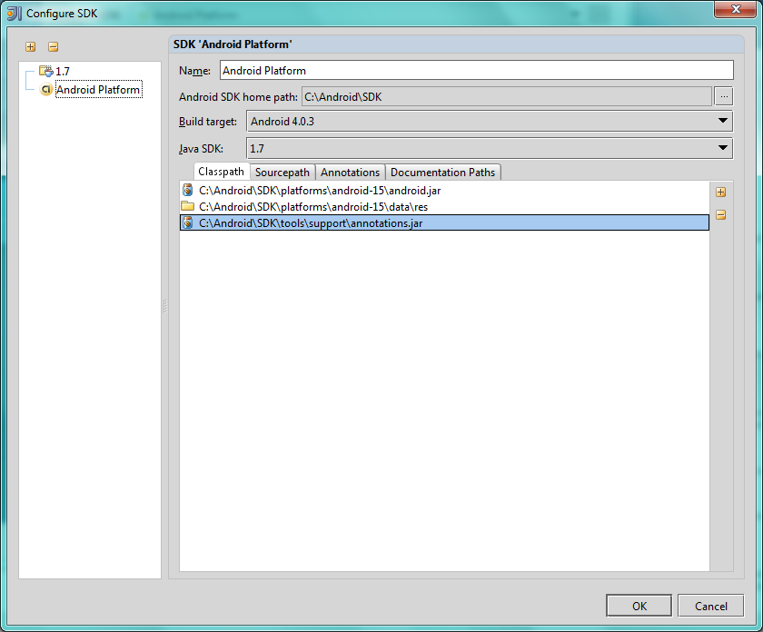

Step 5: Run the application, if you have choose target device as Emulator, then you would get the output as shown.

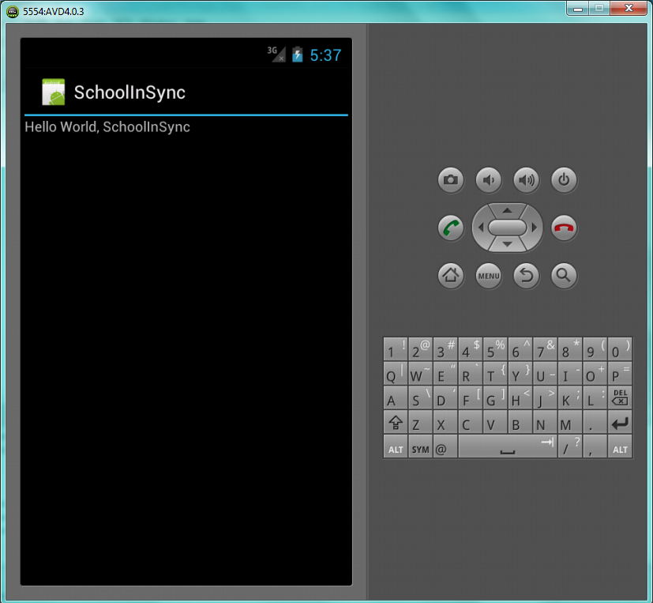

Step 6: Create a new folder “www” in the assets folder and copy cordova.js into that folder and also copy jQuery.js, jQuery.mobile.js, jQuery.mobile.css.

Create index.html and reference all the above files.

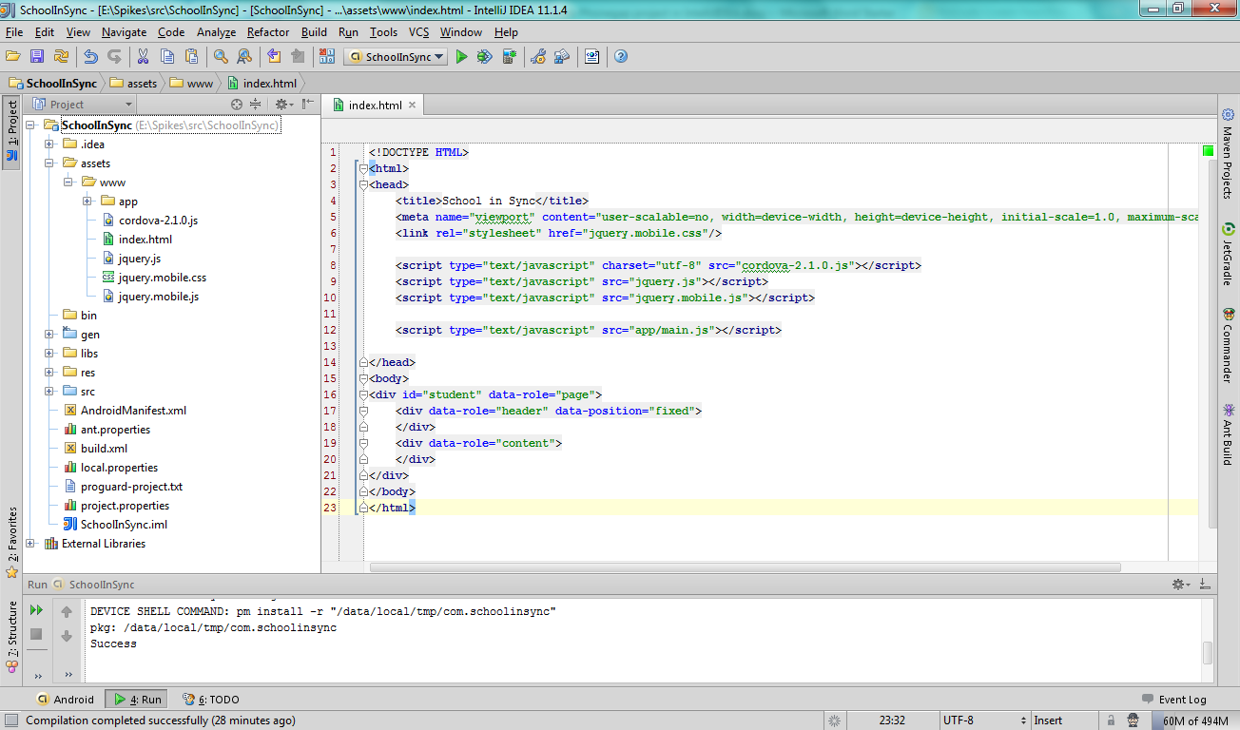

Step 7: select project folder and then click F4 to launch the project properties. Goto libraries in the left side menu bar. Then click the + symbol and then select java option.

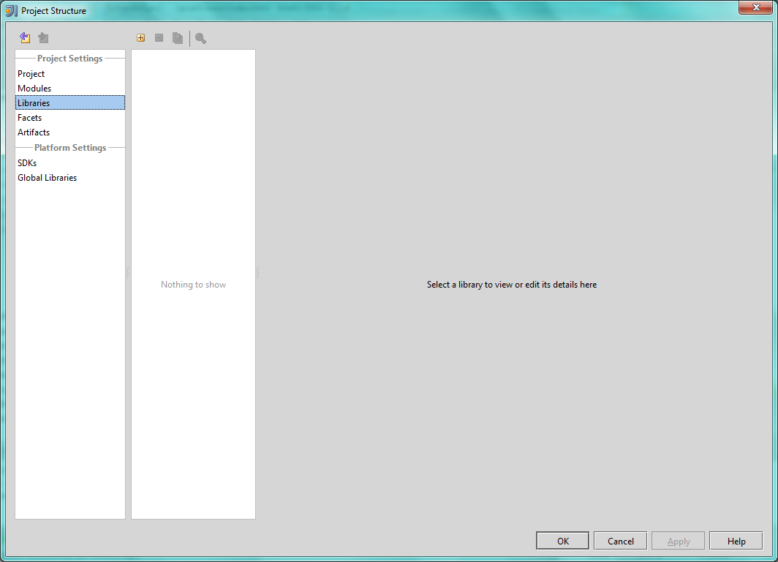

Select the cordova.jar file from the project location

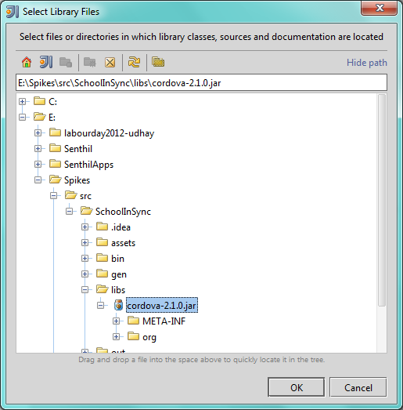

Step 8: Open the AndroidManifest.xml file.  Paste the following between the 

<uses-sdk...>

and the 

<application...>

tags.

<supports-screens

android:largeScreens="true"

android:normalScreens="true"

android:smallScreens="true"

android:resizeable="true"

android:anyDensity="true" />

<uses-permission android:name="android.permission.VIBRATE" />

<uses-permission android:name="android.permission.ACCESS_COARSE_LOCATION" />

<uses-permission android:name="android.permission.ACCESS_FINE_LOCATION" />

<uses-permission android:name="android.permission.ACCESS_LOCATION_EXTRA_COMMANDS" />

<uses-permission android:name="android.permission.READ_PHONE_STATE" />

<uses-permission android:name="android.permission.INTERNET" />

<uses-permission android:name="android.permission.RECEIVE_SMS" />

<uses-permission android:name="android.permission.RECORD_AUDIO" />

<uses-permission android:name="android.permission.MODIFY_AUDIO_SETTINGS" />

<uses-permission android:name="android.permission.READ_CONTACTS" />

<uses-permission android:name="android.permission.WRITE_CONTACTS" />

<uses-permission android:name="android.permission.WRITE_EXTERNAL_STORAGE" />

<uses-permission android:name="android.permission.ACCESS_NETWORK_STATE" />

<uses-permission android:name="android.permission.GET_ACCOUNTS" />

<uses-permission android:name="android.permission.BROADCAST_STICKY" />

Step 9: Copy xml folder from Cordova/android source file and add it to project res folder.

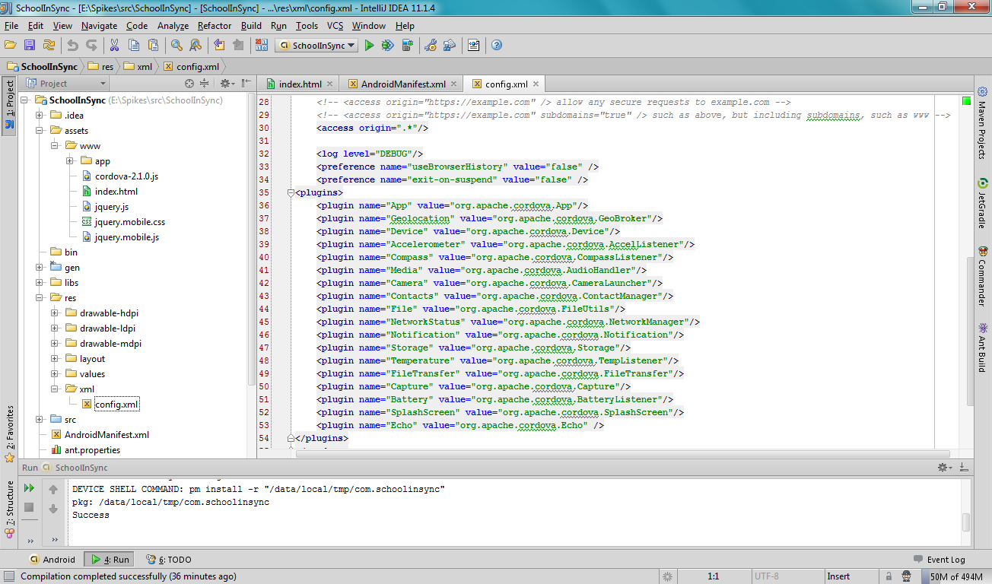

Step 10: Run the application, you should be able to see the page in the screen.

